Cathodic Drilling Services

[Overview]

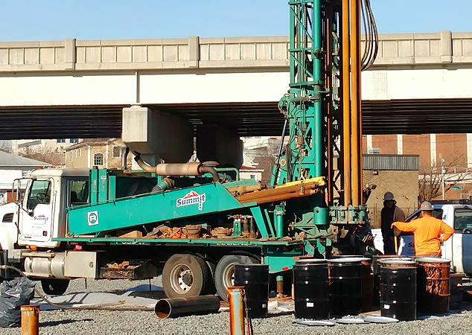

[Icon] INDUSTRIES SERVED
Cathodic Drilling Services
Drilling that helps protect what matters most

[Main content well]
Summit delivers precise cathodic protection boreholes that safeguard pipelines, tanks, and other buried infrastructure to reduce corrosion risks, extend asset life, and help operators avoid costly failures.

A cathodic protection system, and more specifically cathodic protection system installation, is all about protecting critical infrastructure, especially for oil or gas pipelines where premature erosion can result in serious costs and environmental impacts.

Summit understands the importance of effective and efficient cathodic protection well drilling so that protective systems can be installed that will extend the life and safety of underground infrastructure. More than experience alone, Summit’s field crews are all OSHA and HAZMAT certified. We do more than check off boxes when it comes to health and safety, we’ve embraced it as part of our corporate culture.

If you need cathodic drilling, let Summit help you protect your critical infrastructure. We are experts at cathodic drilling boreholes and cathodic protection system installation.

We’ll contribute to your approach and provide a prompt and cost-effective proposal. Count on Summit for An Exceptional Experience.

Summit’s Lauren DiVello is a dedicated and experienced customer advocate. Reach Lauren at 609-238-2815 to discuss your project needs. Or email LDivello@SummitDrilling.com and she will reply promptly.

[Stat-a-Project Form]

